To configure SNMPv3 on an HP switch
To configure SNMPv3 on an HP switch, follow these steps. The configuration might vary slightly based on the switch model and firmware version, but the general steps should be similar.
Steps to Configure SNMPv3 on HP Switch:
- Access the Switch CLI
Log in to the switch through the console or via SSH with admin privileges.
- Enable SNMP
SNMP is often enabled by default on HP switches. However, you can check and enable it manually if necessary:
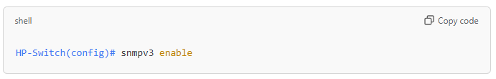
- Create an SNMPv3 User
Define a new user with specific authentication and privacy (encryption) parameters. You need to specify an authentication and/or encryption method:
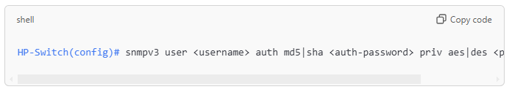
  - <username>: Replace with the SNMPv3 username you want to create.
  - <auth-password>: Password for authentication.
  - <priv-password>: Password for encryption.
  - For auth (authentication), choose either md5 or sha hashing.
  - For priv (privacy), choose either aes (recommended) or des.
- Configure SNMPv3 Group
Assign the user to an SNMPv3 group with specific access privileges. Here’s an example of setting it up with read-only access:
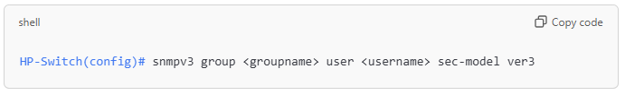
  - <groupname>: A custom name for the SNMPv3 group.
  - <username>: The SNMPv3 username you configured earlier.
- Configure SNMP Views
Define the MIB views for the group, specifying what parts of the MIB are accessible:
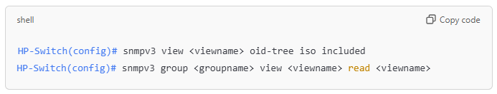
  - <viewname>: A name for the view.
  - oid-tree iso: Grants access to the entire MIB tree.
- Set Trap Destinations (Optional)
If you need the switch to send SNMP traps, configure a trap destination:
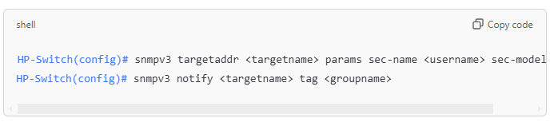
  - <targetname>: A name for the trap target.
  - <username>: The SNMPv3 username created earlier.
- Verify SNMPv3 Configuration
Check the configuration to confirm SNMPv3 settings:
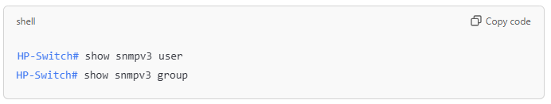
Example Configuration
Here’s a full example configuration for an SNMPv3 user snmpuser with read-only access and using SHA and AES for encryption:
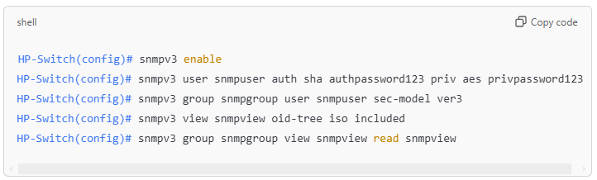
Important Notes:
- Passwords: Use complex passwords for both auth and priv to enhance security.
- Authentication and Privacy Protocols: SHA and AES are recommended for better security.
- Access Control: Limit SNMP access to trusted IP addresses or specific networks to enhance security.
This setup provides a secure SNMPv3 configuration, ensuring encrypted communication and authentication with the switch.

